

USEFUL JAPANESE DICTIONARY FOR VIETNAMESE

INSTALLATION GUIDE DOCUMENT

**Project Code: UJD_VN**

**Document Code: UJD_VN_Installation Guide_v1.0_EN**

**Ha Noi, 15/08/2014**

Record of change

*A - Added M - Modified D - Deleted

|  |  |  |  |  |
| --- | --- | --- | --- | --- |
| Effective Date | Changed Items | A* M, D | Change Description | New Version |
| 15/08/2014 |  | A | Add new | v1.0 |
|  |  |  |  |  |
|  |  |  |  |  |
|  |  |  |  |  |
|  |  |  |  |  |
|  |  |  |  |  |
|  |  |  |  |  |
|  |  |  |  |  |
|  |  |  |  |  |
|  |  |  |  |  |
|  |  |  |  |  |
|  |  |  |  |  |
|  |  |  |  |  |
|  |  |  |  |  |
|  |  |  |  |  |
|  |  |  |  |  |
|  |  |  |  |  |
|  |  |  |  |  |
|  |  |  |  |  |
|  |  |  |  |  |
|  |  |  |  |  |

SIGNATURE PAGE

ORIGINATOR: Phạm Tiến Đạt 15/08/2014

Team member

REVIEWERS: Nguyễn Ngọc Tuấn 16/08/2014

Team member

APPROVAL: Nguyễn Văn Sang 16/08/2014

Supervisor

# Installation guide

## Introduction

This document contains guide-lines step by step to use UJD_VN website, and set up its own database.

## Environment

Following are the software required to start the UJD_VN System:

* Operating System: Windows 7, WinXP, Win8
* Browsers: Firefox 20, Chrome 36 or higher.
* Database: MySQL 5.6.16 or higher
* Xampp 1.8.3/ PHP 5.5.11

## Application Installation

### Set up Environments:

* Web: If users want to use UJD_VN system on personal computer, users need to install Chrome36 /Firefox 20 or higher version and MySQL to create and store database.
* Server: Xampp 1.8.3

### Installation Xampp 1.8.3

Go to link: http://toidongianchannel.wordpress.com/2014/03/31/huong-dan-cai-dat-localhost-bang-phan-mem-xampp-server/ and follow the guides

### Create Database

* After set up Xampp 1.8.3, start XAMPP Control Panel :

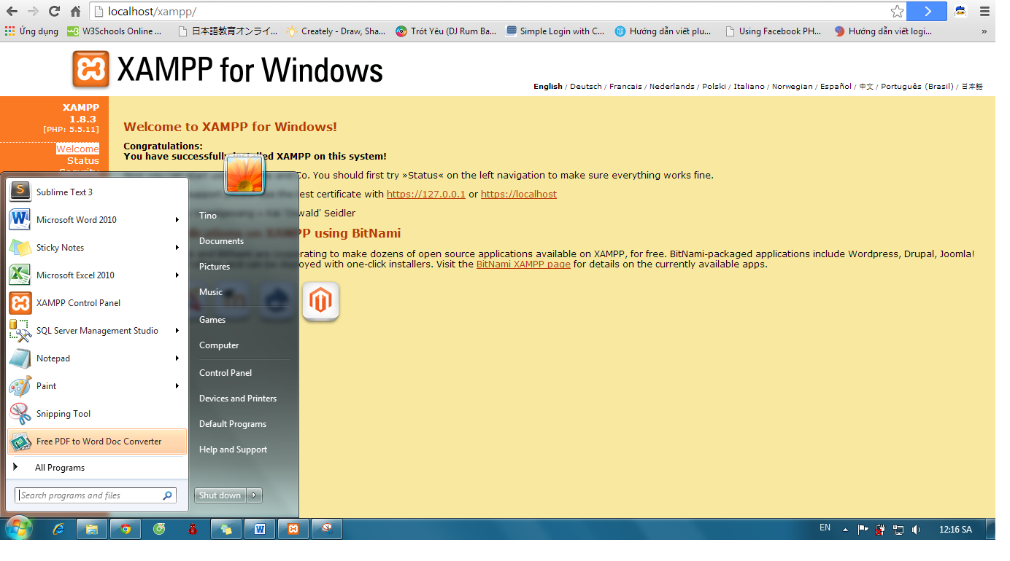

* Click “Start” of Apache and MySQL:

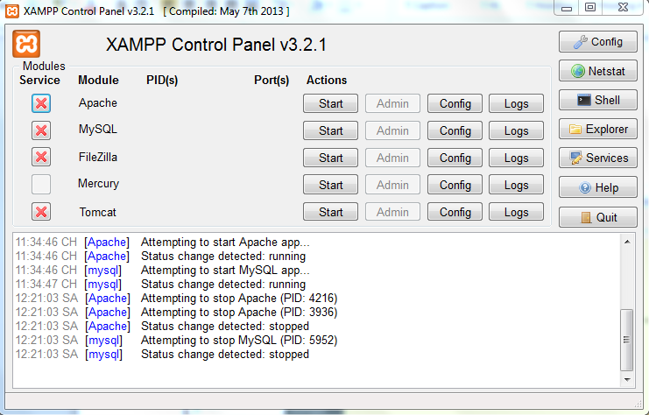

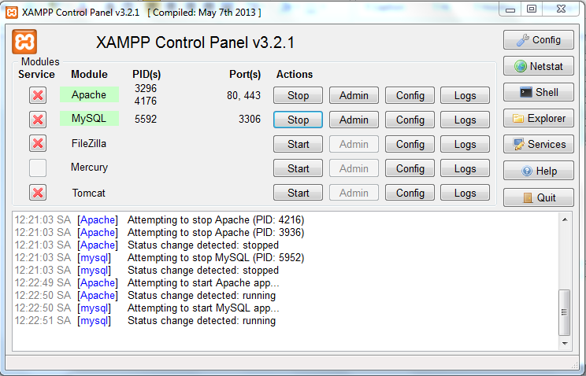

* Go to link: http://localhost/xampp/ and click on phpMyAdmin

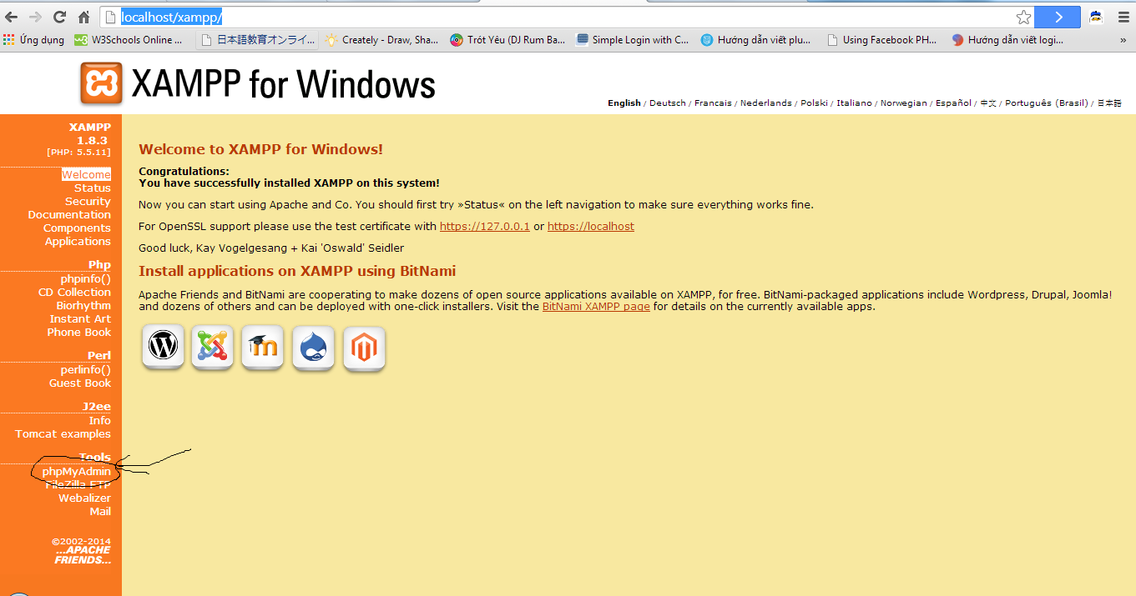

* Click on “New” to create a new database with name as “japanesedictionary” and collation “utf8_general_ci”. After click “Create”

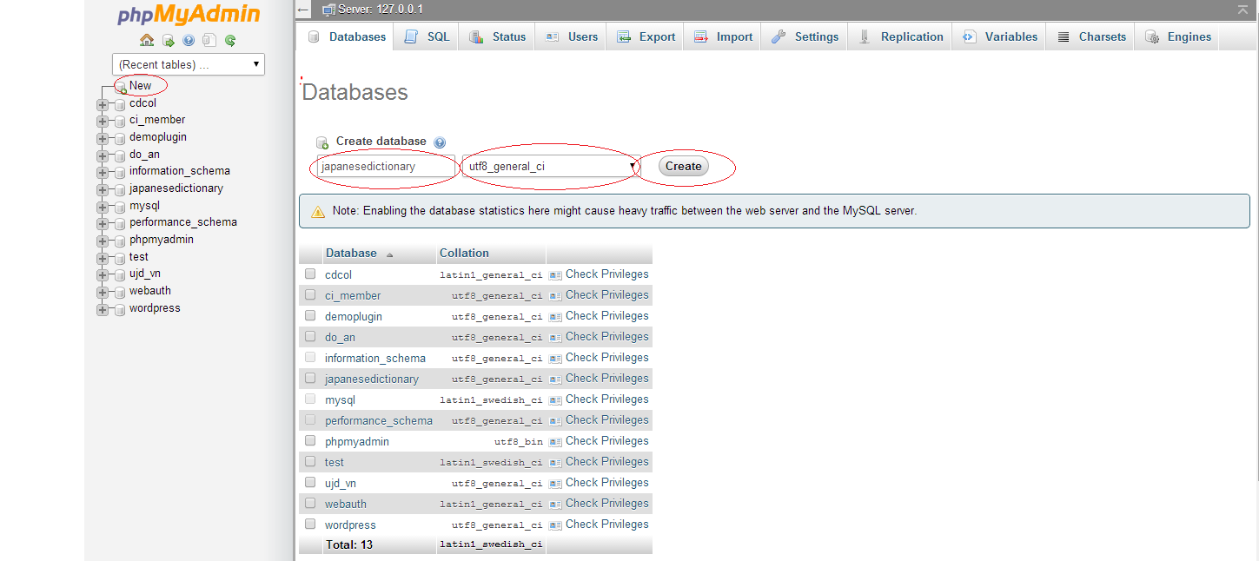

* After click “Create”, a new database were created with name as “japanesedictionary”

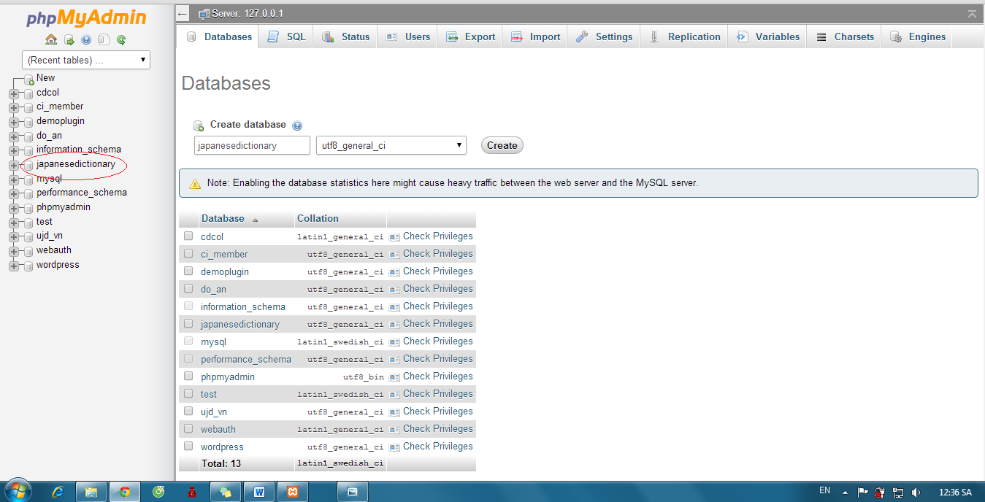

* Click “japanesedictionary” and “Import” :

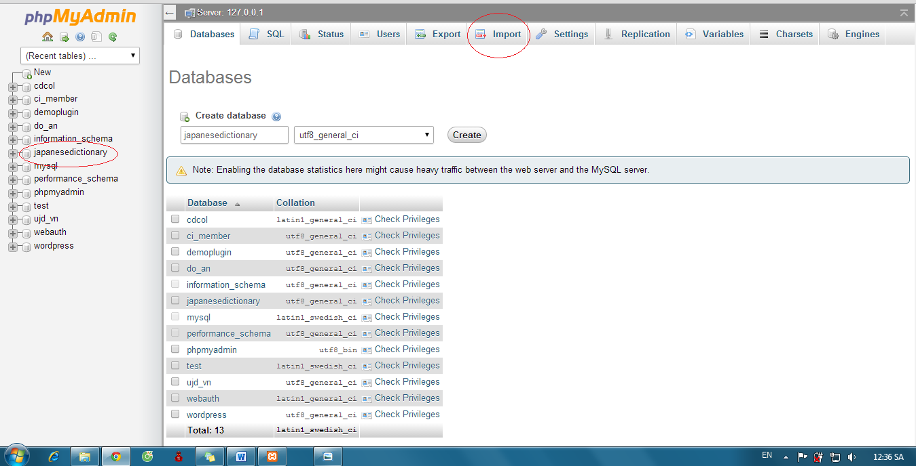

* Click “Chọn tệp” button:

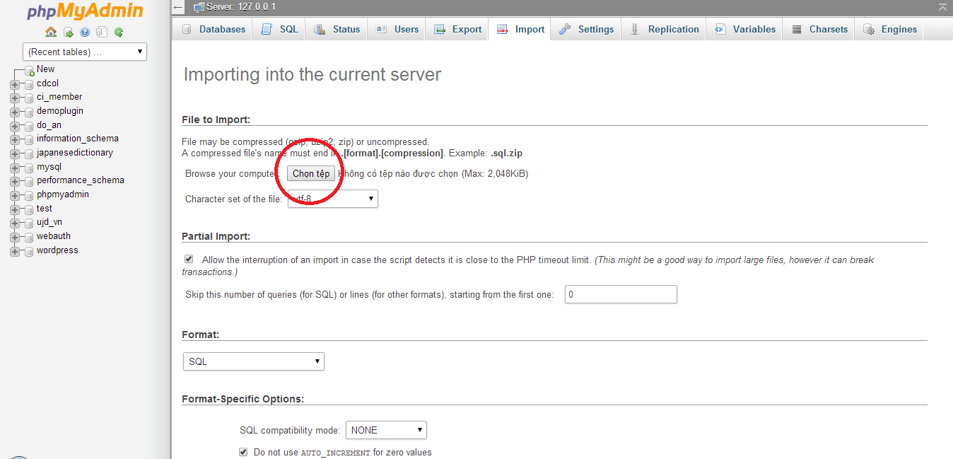

* Select file “japanesedictionary.sql”

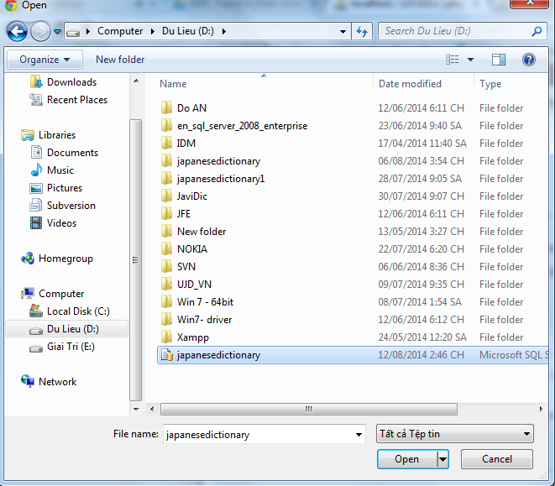

* Click “Go”

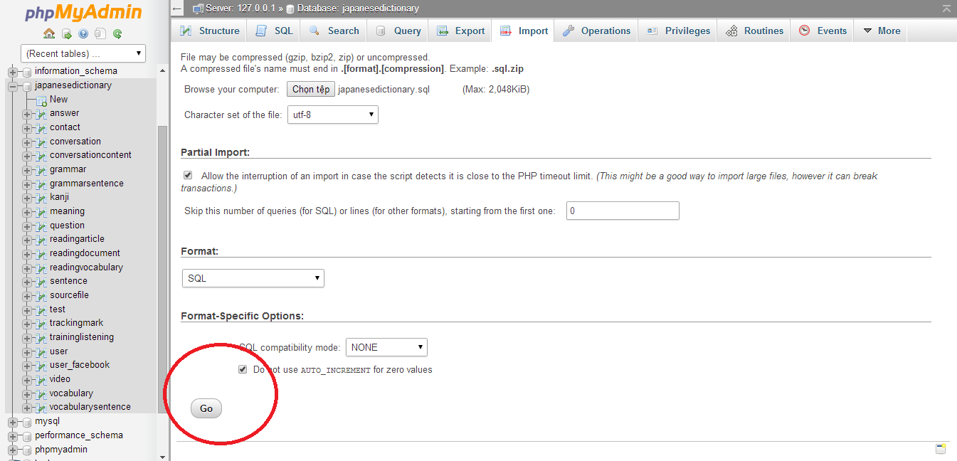

* Database was created with some table that contained data 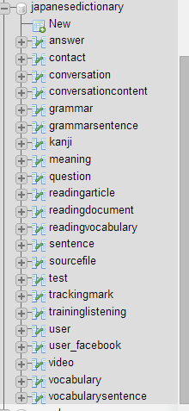

### Installation Web Application

Step 1: Preparing package japanesedictionary.rar. Make sure package is available (incorrupt).

Step 2: Move package to htdocs folder of folder which installed xampp server (:..\Xampp\htdocs)

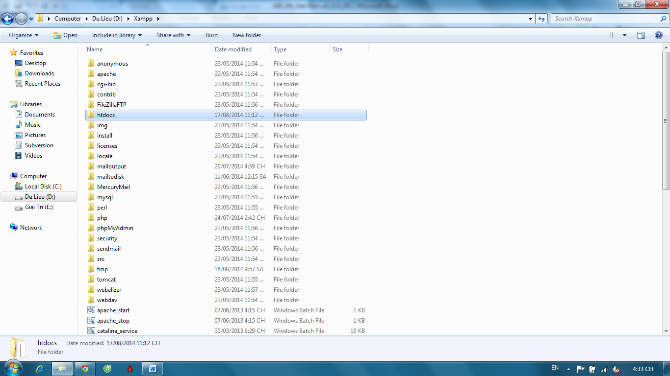

Step 3: Extract file japanesedictionary.rar, select “Extract here”

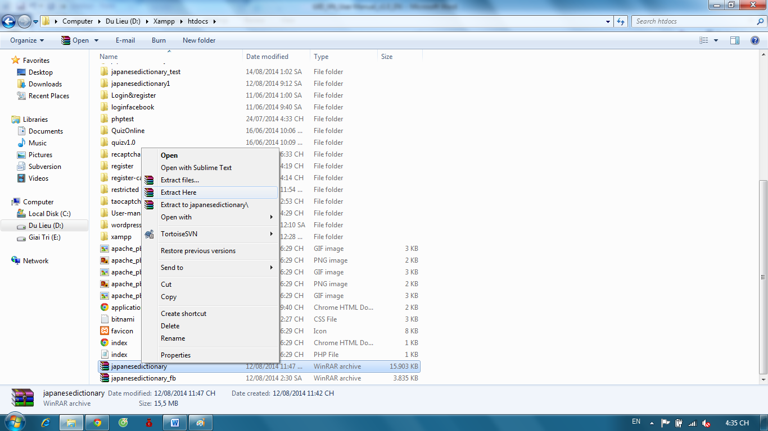

Step 4: Open Browser (Chrome or Firefox) and go to link http://localhost/japanesedictionary/index.php/Home/verify/login or http://localhost/japanesedictionary/index.php/Admin/verify/login

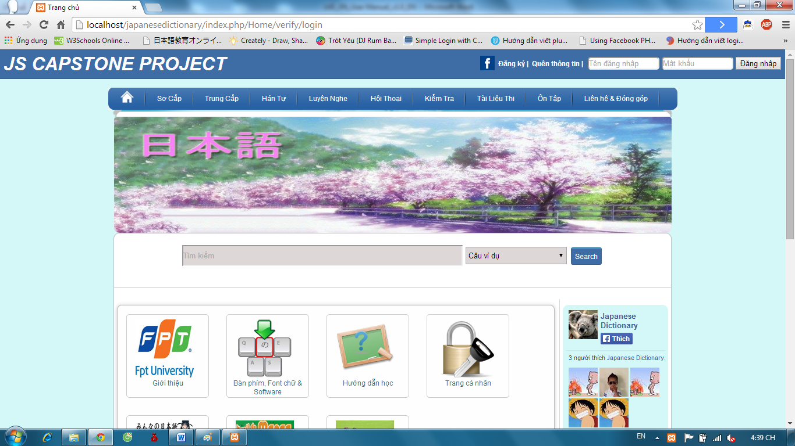

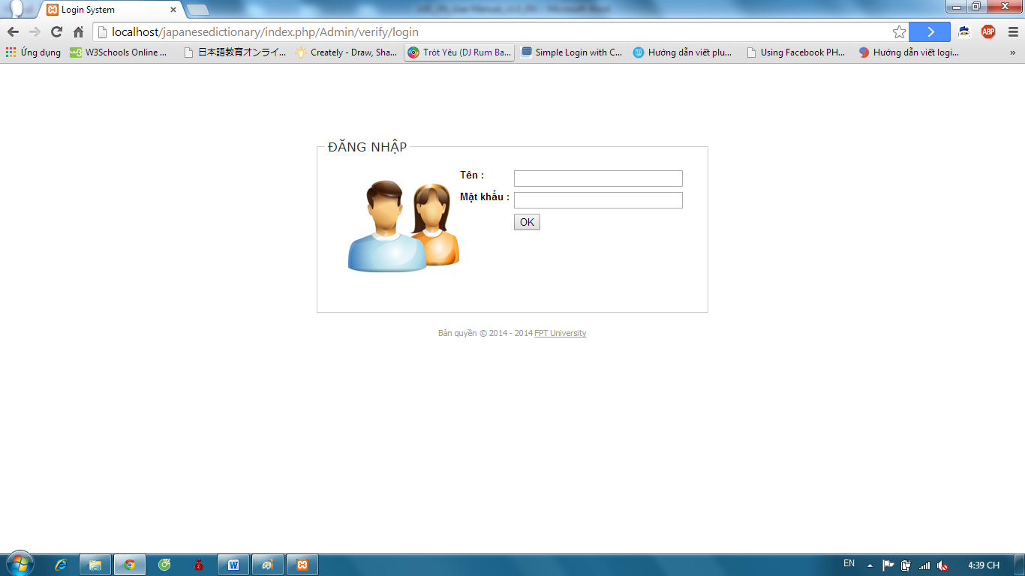

# Appendix

* UJD_VN_Software requirement specification_v1.2_EN
* UJD_VN_Defects Log Management_v1.0_VN
* UJD_VN_Q&A Management Sheet_v1.0_JS